**FAKE NEWS**

**DETECTION**

**NLP**

**Team Leader:**

**Santhoshi Atthili**

**Team Member:**

**Bhavya Kethineni**

**FROM**

**Vignans Institute Of Management And Technology For Women(VMTW)**

**ABSTRACT**

In the age of digital media, fake news is a serious problem because it spreads misinformation and harms individuals, organizations, and even entire nations which is a challenging aspect. This study proposes a machine learning approach for detecting fake news. In the proposed approach, a categorization model is developed with four different types of machine learning algorithms, evaluating the content and aesthetic components of news stories. The performance of the proposed model is analyzed by using a large dataset of real and fake news articles and the results show that it outperforms many existing systems. The proposed findings demonstrate the potential of machine learning techniques, such as logistic regression, decision tree, random forest, and passive aggressive algorithms to address the fake news detection challenges.



**INTRODUCTION**

The introduction of the internet and the rapid evolution of social media platforms such as Facebook and Twitter have outdated newspapers, magazines, articles etc which were the main source of valid information. The social media platforms are extremely powerful in their current state are and known for their ability to allow users to discuss and share ideas. But introduction of such platforms are also used in a negative way by certain people or organizations in the society commonly for monetary gain and in other cases for creating their own opinions, manipulating and misguiding peoples mindsets. This process is generally what we call spreading fake news which can be really dangerous and extremely harmful. There have been a large number of reports everyday regarding fake news. Many articles go hand to hand in seconds without knowing whether it is even real or fake. One such area affected by fake news is the public sectors, where a rumour can bring disastrous consequences and may bring the state to halt. Normally we take decisions based on the type of news we hear. If we hear fake news then unknowingly we take wrong steps which might cost us. These characteristics can be used to identify the affects of fake news of humanity

Detecting fake news won’t end the trauma of spreading them ,detecting fake news articles, identifying the fake news creators and subjects will actually be more important, which will help completely remove a large number of fake news from the roots. Basically when news is created all the information regarding author is also given, but in worst cases blind news gets forwarded hence we need to find and eradicate this from the starting stage itself. Even general public has a major role in spreading of news be it fake or real. People should not forward any news which they get to others without knowing whether it is real or fake. Our study signifies the nature of the news by its textual formation and content. It does so by comparing it with many articles which are real ones. By using those properties, we train a combination of different machine learning algorithms using various methods. We try to put the best solution possible and help to eradicate the problem as much as possible.

* 1. **Challenges**

There are various social media platforms such as Facebook and Twitter. Etc ich people rely on news updates. In these forums, any user can create posts or spread news. However, these forums do not guarantee posts. As a result, some users deliberately spread false stories in these forums to tarnish the image of the company or person

. • The online system leads to the mass production of false news content. Misleading content produced by someone to undermine the dignity of individuals or firms.

• False news broadcasters can do this to claim Ransome. It is not good for the community at all if it continues. Spam senders see this as an opportunity to make money with spam in the news on an ongoing basis.

• Identifying false stories on social media is a challenge because of their versatility. Since spam senders are always on the news in order to make money, news comes from everywhere online.

• The widespread of false news has the potential to have far-reaching effects on individuals and communities. People's opinions can also change in that company or person.

• False news can distort the authenticity of the news ecosystem for example; it is clear that the most popular false news was more widespread on Facebook than the most widely accepted real news during the U.S. presidential election. 2016.

• False stories deliberately entice consumers to simply accept biased or false beliefs. False stories are often used by propagandists to spread political messages or influence, for example, one report suggests that Russia created fake accounts and public bots to spread lies.

• Counterfeit stories change the way people interpret and respond to real stories, for example, some false stories have just been created to arouse mistrust and confuse people; hindering their true and false distinction skills.

• Personally, determining the authenticity of a story is a challenging task, often requiring annotations with domain experts who carefully analyze claims and further evidence, context, and reports from authoritative sources.

* 1. **Solutions to the challenges**

There are so many problems people are facing in this modern world because of the spread of false news. Any user can easily mislead the public by posting untrue content on social media. People should be aware of false stories on social media. The issue of fraudulent news has received a lot of attention from research communities and requires a very efficient and low-cost solution. Existing identification methods are based on news content or social media using user-based features as an individual. false news has seen unprecedented growth during the 2016 US presidential election. This opened the way for researchers and other stakeholders to find a lasting solution. There have been a variety of solutions developed to help people distinguish between false and real issues however, solutions depend on a machine-based approach or a person-based discovery. Many commercial solutions have been developed using these methods such as browser extensions and native applications. For example;

1) The Official Media Impartiality and Truth Extension is based on companies and uses a comprehensive bias library to report bias.

2) B.S. Detector is based on URL. Searches all links on a given web page to find reference to unreliable sources. It then gives us a clear warning about the existence of questionable links or browsing questionable websites.

3) FiB analysis is both URL-based, corpus-based and image-based. It provides an algorithm that gives the user credible points. If the algorithm finds the post to be false, it tries to find the truth and show it to the user.

4) PolitiFace is a traditional app that provides "True-O-Meter" to measure the accuracy of a news item.

5) Specialist-based authentication relies heavily on personal domain experts to investigate relevant data and documents in order to formulate claims for authenticity. for example, PolitiFact11, Snopes12, etc. However, expert-focused verification is a process that requires ingenuity and time, limiting the effectiveness of high efficiency and durability.

6) Criticism-based analysis of crow dourcing uses “crowd intelligence” so that ordinary people can interpret the content of the news; these annotations are then compiled to produce a complete overview of the authenticity of the news. For example, Fiskkit13 allows users to discuss and explain

the accuracy of certain parts of a news article. As another example, an anti-fraud news button called “Real” is a public account on the LINE14 instant mobile app, which allows people to report suspicious news content that is also reviewed by editors.

7) A computational proof-based examination aims to provide an automated measurement system to distinguish true and false claims. Statisticalbased assessment methods attempt to solve two major problems: (i) identifying claims that need to be considered and (ii) discriminating the validity of claims.

**1.3 Overview**

Everyone relies on a variety of online resources for news. It changes the way people use information and news from traditional to digital, resulting in comfort and speed for both newsletters and news readers. With so many social media platforms like Facebook, Twitter etc., news is spreading fast among millions of users because social media has made it easier to share information. It makes it easy to access and share data and technology transformation. It is so easy to produce news in these forums that there may be false stories. Fake news has become one of the main concerns as it can undermine governments that put modern society at risk.

The widespread spread of false news can have a devastating effect on individuals and communities. First, false news can distort the authenticity of the news ecosystem. false stories deliberately encourage consumers to simply accept biased or false beliefs. Determining and minimizing the impact of untrue stories is one of the main problems of modern times and is gaining widespread attention. While truthful websites like Snopes, PolitiFact, and big companies like Google, Facebook, and Twitter, took the first steps to deal with untrue issues.

Many societies, including machine learning, database, journalism, political science, and more, pay attention to aspects of false news as a cover subject. There is still much to be done to address the issue of fraud. There have been a variety of solutions developed to help people distinguish between false and real issues however, solutions depend on a machinebased approach or a person-based discovery. Although there has been an increase in the number of studies focusing on the analysis and research of false stories and / or aspects of rumors in order to better identify and extract false information, there is still ample space for research in this way as it is not a fully integrated solution. First, false news can distort the authenticity of the news ecosystem. false news deliberately entices consumers to simply accept biased or false beliefs. False stories are often used by propagandists to

spread political messages or influence, for example, one report shows that Russia has created fake accounts and public bots to spread lies. counterfeit stories change the way people interpret and respond to real stories, for example, some false stories have just been created to provoke mistrust and confusion; interfering with their ability to distinguish truth from falsehood. Therefore, stopping the spread of these false stories and rescuing innocent people from false news broadcasters and detecting spam of illegal news in advance is very important. The false news detection project aims to give the user the ability to classify news as false or real. In order to determine whether a story is true or false, the model must be constructed using a variety of techniques. We use Natural Language Processing in our project as it deals with construction equipment that easily understands and responds to text or voice data in the same way as humans. With native language processing, machines can even perform tasks on spoken or written text. The Python system provides a variety of libraries and tools for various NLP tasks. Natural Language Toolkit is a collection of opensource resources, programs, and resources for building NLP programs. Natural language processing apps for speech recognition, emotional analysis, question / answer systems, chatbots, etc. The data processing techniques we use in our project are Lemmatization, Tokenization, Stemming, stop words (methods used to break sentences into tokens and abbreviated words) and Vectorization. After preprocessing the data vectorization can be performed on pre-processed data to convert text to numerical representation. We have used a translator to determine if the news is true or false when the data is provided in any language. This is how false media coverage can be done using artificial intelligence to save innocent people from fraudulent news and senders of spam. False news detection aims to give the user the ability to classify news as false or real.

**SYSTEM REQURIMENT**

**SOFTWARE REQURIMENTS**

* Programming Language: Python is commonly used for NLP tasks due to it extensive libraries such as NLKT, scikit-learn for deep learning.
* Development Environment : DEs like Jupyter Note book, Pycharm or Visual Studio code.
* Database Management System (DBMS): Optional for storing large datasets efficiently.

Example: SQLite , MySQL or MongoDB.

**HARDWARE REQURIMENTS**

* Sufficient computational resources(CPU/GPU) for training ,interface,depending on the size of the dataset and complexity of the model.
* Storage space for storing datasets,trained models and intermediate results.

**DATA REQURIMENTS**

* Access to labeled datasets containing both real and fake news articles.
* Diverse sources to ensure the models’s robustness across different contexts.
* Annotation guidelines for labeling news articles as real or fake.
* Data preprocessing tools to clean and prepare the text data for analysis.

**NLP LIBRARIES AND TOOLS**

* NLTK (Natural Language Toolkit) or SpaCy for text preprocessing, tokenization, and lemmatization**.**
* Scikit-learn for feature extraction, dimensionality reduction, and machine learning algorithms**.**
* TensorFlow or PyTorch for building and training deep learning models.
* Word embeddings (pre-trained or custom) for capturing semantic meanings of words.
* Transformer architectures (BERT) for advanced language understanding.
* Evaluation metrics libraries such as scikit-learn or TensorFlow/Keras metrics for assessing model performance.

**LITERATURE REVIEW**

* Meesad Information published online may contain both factual or non-factual news. Therefore, the discovery of fake news should be done to save innocent people from fraudulent news broadcasters and spammers. In this paper, the author has suggested the study of natural language in order to detect counterfeit information as it relates to interactions between humans and computers. It is a way of processing and analyzing large amounts of native language data.
* Uma Sharma The purpose of this paper is to give the user the ability to classify news as fake or real and to check the authenticity of the news publishing website. In this paper, four different machine learning algorithms such as Naïve Bayes, Random Forest and Logistic regression algorithms are used for classification. Dataset used in this paper LIAR: This database is compiled on the fact-checking website PolitiFact by its API. Includes 12,836 brief statements from people.
* Sakeena By using the algorithm to detect false stories, innocent people can be saved. Therefore, this paper introduces a performance test of algorithms, which is able to detect and filter at the appropriate level of accuracy. Suggested method is a multi-layered test method that will be built as an application.
* Zervopoulos In this paper, the author has suggested the use of natural language in order to detect false news on social media platforms on Twitter. The ML algorithms used for pre-feature processing and selection methods are considered. Literature has seen the effectiveness of the use of Naive Bayes, SVMs (Vector Support Machines) and Decision Trees to predict the accuracy of news.
* Kushal Agarwalla, In this paper, NPL (pre-natural processing languages) NLTK algorithms used NLTK in python were used to make the body token and title. Deleting stops (refers to the list of NLTK stops), helped to increase all data. The algorithmic method of machine learning used in this paper is the Naïve Bayes algorithm The accuracy of the model is 74.5%
* **Fake News Detection on Social Media**

A Data Mining Perspective" by Shu, K. et al. (2017)

This paper focuses on fake news detection on social media platforms. It discusses the

challenges of identifying fake news and proposes a framework that utilizes NLP techniques such as textual analysis and sentiment analysis to classify news articles as fake or real.

* **“Detecting Fake News with Deep Learning” by Yang, K. et al. (2018)**

Yang et al. present a deep learning approach to detect fake news. Their model utilizes convolutional neural networks (CNNs) and long short-term memory networks (LSTMs) to capture semantic features from news articles and social media posts. NLP techniques are employed for text preprocessing and feature extraction.

* **“Linguistic Features for Fake News Detection**”

Evidence from a Corpus of Fake News vs. Satire" by Rubin, V. L. et al. (2016)

This paper explores linguistic features that distinguish fake news from satire. It discusses linguistic cues such as sentiment, complexity, and lexical diversity, which are leveraged for fake news detection using NLP methods like machine learning classifiers.

**EXISTING LIMITATION**

**Context Understanding:** NLP models often struggle with understanding context, sarcasm, irony, and other nuanced linguistic elements. Fake news can exploit these ambiguities to appear genuine**.**

**Data Quality and Quantity:** The effectiveness of NLP models heavily depends on the quality and quantity of training data. Gathering labeled datasets of fake news can be challenging due to its dynamic and subjective nature**.**

**Language and Cultural Bias:** NLP models trained on certain languages or datasets may exhibit bias, leading to inaccuracies in fake news detection, especially in multilingual or culturally diverse contexts.

**Adversarial Attacks:** Adversarial attacks involve modifying inputs in a way that's imperceptible to humans but can fool NLP models. Fake news creators can employ such techniques to evade detection systems.

**Temporal Dynamics:** Fake news evolves rapidly, and NLP models may struggle to adapt quickly to new patterns and trends, leading to a lag in detection.

**Multimodal Content:** Fake news often includes images, videos, and other multimedia elements. NLP models primarily analyze text and may miss crucial cues present in other modalities**.**

**Source Dependence**: NLP-based fake news detection often relies on identifying unreliable sources. However, this can be challenging as the credibility of sources can vary based on context and may change over time.

**Privacy Concerns:** Accessing and analyzing large amounts of data to train NLP models for fake news detection raises privacy concerns, especially when dealing with sensitive information or personal data.

**Legal and Ethical Considerations:** Determining what constitutes fake news involves complex legal and ethical considerations. NLP models may inadvertently propagate biases or restrict freedom of speech if not designed and used responsibly.

**User Behavior Analysis**: Fake news detection could benefit from considering user behavior and social network dynamics. However, collecting and analyzing such data raises privacy and ethical concerns, and it may not always be reliable

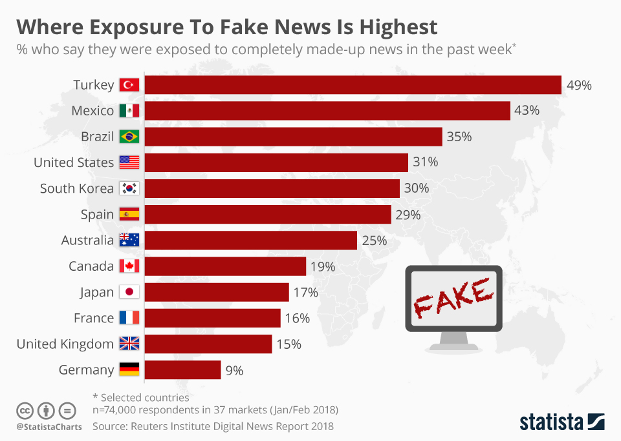

**Methodology**

**Proposed model:**

Our Proposed Model is Natural Language processing. Natural language processing is a form of Artificial Intelligence based on construction equipment that can easily understand and respond to text or voice data in the same way as humans. With NLP, machines can even perform tasks with spoken or written text. Steps Involved in Natural Language processing are Data pre-processing, Tokenization, stemming, Lemmatization and vectorization.

.



**Fig 1: Flow chart of our model**

**DATA PRE-PROCESSING:**

Data pre-processing is the first and most important step in the development of machine learning models as it is concerned with preparing raw data and adapting the machine learning model. The Natural Language Toolkit includes libraries for NLP activities such as stemming, lemmatization, stopwords (methods used to break sentences into tokens and word breaks) etc.

1. **Lemmatization:**

Lemmatization is a method used to reduce tokens to a standard form i.e., the form of a root dictionary. This process looks at morphological analysis of words to translate words into a common form.

1. **Stemming:**

Stemming is a form of reducing a word into its own vocabulary that is, the base of words. Stemming basically removes a suffix from a word and cuts it into its root. This process uses a noun stem.

1. **Stopwords:**

Stop words are used to remove non-essential words, allowing applications to focus on keywords instead.

4**. Vectorization**:

Vectorization jargon is an old method of converting input data from its raw format (i.e., text) into real number vectors which is a format supported by ML models. This approach has been around since the advent of computers, works wonders in a variety of domains, and is now widely used in NLP. We have TF-IDF.

1. **TF-IDF:**

TF stands for Term Frequency. It can be understood as a general effect of frequency. IDF stands for Inverse Document Frequency, but before we go into IDF, we have to make sense of DF - Document Frequency

**SYSTEM ARCHEITURE**

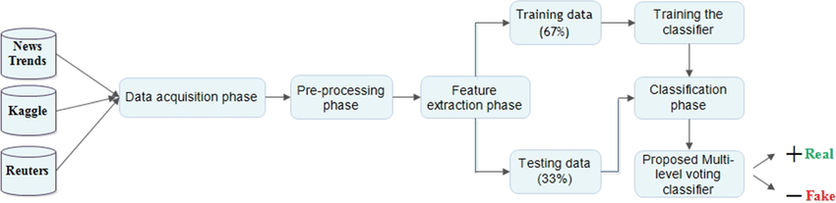

Fig1: Architecture of the proposed automatic fake news detection system

**DATA COLLECTION**

The first step involves gathering a large dataset of news articles or content. This dataset should ideally include both real and fake news articles to train the model effectively

**PREPROCESSING**

Before feeding the data into the NLP model, preprocessing is done to clean the text and prepare it for analysis. This includes tasks such as tokenization, lowercasing, removing punctuation, stop words, and special characters, as well as stemming or lemmatization.

**FEATURE EXTRACTION**

In this step, features are extracted from the preprocessed text data. These features could include word frequency, n-grams, syntactic features, semantic features, and other linguistic features that help the model understand the content of the text.

**MODEL BUILIDING**

Various machine learning or deep learning models are employed to classify news articles as real or fake based on the extracted features. Common approaches include.

SUPERVISED LEARNING

Using algorithms like Support Vector Machines (SVM), Random Forest, Naive Bayes, or Logistic Regression trained on labeled data.

DEEP LEARINING

Utilizing neural network architectures such as Convolutional Neural Networks (CNNs), PAC, Recurrent Neural Networks (RNNs), Long Short-Term Memory (LSTM) networks, or Transformer-based models like BERT or GPT.

**TRAINING**

The model is trained on a labeled dataset of news articles, where each article is labeled as real or fake. During training, the model learns to distinguish between real and fake news based on the features extracted from the text.

**EVALUATION**

The trained model is evaluated using a separate validation dataset to assess its performance in terms of accuracy, precision, confusion matrix other relevant metrics.

**DEPLOYMENT**

Once the model achieves satisfactory performance, it can be deployed into a production environment where it can process new news articles in real-time or batch mode. This deployment might involve integrating the model into a web application, API, or other software system.

**MOINTORING AND MAINTENANCE:**

Continuous monitoring is essential to ensure that the model performs well over time. Monitoring may involve tracking model performance, retraining the model periodically with new data, and updating the system architecture as needed to adapt to changing trends in fake news dissemination.

**Machine Learning models**

Machine learning models are used to predict the correct label for the given test data. So, supervised learning algorithms such as Passive Aggressive Classfication(PAC) and SVM algorithms.

Passive-Aggressive algorithms are a family of Machine learning algorithms that are popularly used in big data application. Passive-Aggressive algorithms are generally used for large-scale learning. It is one of the **online-learning algorithms**. In online machine learning algorithms, the input data comes in sequential order and the machine learning model is updated sequentially, as opposed to conventional batch learning, where the entire training dataset is used at once.

This is very useful in situations where there is a huge amount of data, and it is computationally infeasible to train the entire dataset because of the sheer size of the data.

PAC will get a training example, update the classifier, and then throw away the example

A very good example of this would to be detect fake in on a social media website like Twitter, Whatsapp where new data is being added every second.To dynamically read the data from Twitter continuously, the data would be huge, and using an passive aggressive classification would be ideal.

I will provide a use case, where fake news detection by using a passive-aggressive algorithm in python will be performed.

|  |  |
| --- | --- |
|  | import pandas as pd |
|  | import itertools |
|  | from sklearn.model_selection import train_test_split |
|  | from sklearn.feature_extraction.text import TfidfVectorizer |
|  | from sklearn.linear_model import PassiveAggressiveClassifier |
|  | from sklearn.metrics import accuracy_score, confusion_matrix |
|  |  |
|  | #Read the data |
|  | df=pd.read_csv('news.csv')  **Reading the Data and DataFrame**   |  |  | | --- | --- | |  | df=pd.read_csv('news.csv') | |  | #Get shape and head | |  | df.shape | |  | df.head()  https://miro.medium.com/v2/resize:fit:875/1*hcN-s4UMDfv-g-NTJ-0uHA.png |  **Getting the labels from the DataFrame and s**plitting the dataset into training and testing sets.#Get the labelslabels=df.labellabels.head()#Initialize Train and Test Splitx_train,x_test,y_train,y_test=train_test_split(df['text'], labels, test_size=0.2, random_state=7)****Initialize a TfidfVectorizer**** Initialize stop words from the English language and a maximum document frequency of 0.7 (terms with a higher document frequency will be discarded). Stop words are the most common words in a language that is to be filtered out before processing the natural language data. And a TfidfVectorizer turns a collection of raw documents into a matrix of TF-IDF features.  Now, fit and transform the vectorizer on the train set, and transform the vectorizer on the test set.   |  | | --- | | #Fit and tranform the training set and transform the test set | |  | tfidf_vectorizer=TfidfVectorizer(stop_words='english', max_df=0.7) | |  | tfidf_train=tfidf_vectorizer.fit_transform(x_train) | |  | tfidf_test=tfidf_vectorizer.transform(x_test) | |

# ****Initialize a Passive-Aggressive Classifier****

|  |
| --- |
| # Initialize a PassiveAggressiveClassifier |
|  | pac=PassiveAggressiveClassifier(max_iter=50) |
|  | pac.fit(tfidf_train,y_train) |

PassiveAggressiveClassifier(max_iter=50)

# ****Predicting on the test set from the TfidfVectorizer****

|  |
| --- |
| #Predict on the test set and calculate accuracy |
|  | y_pred=pac.predict(tfidf_test) |
|  | score=accuracy_score(y_test,y_pred) |
|  | print(f'Accuracy: {round(score*100,2)}%')  Accuracy: 92.66% |

**Printing out of confusion matrix**

# Build confusion matrix

confusion_matrix(y_test,y_pred, labels=['FAKE','REAL'])

array([[589, 49],  
[ 39, 590]], dtype=int64)

### DATA ANALYSIS

Here I will explain the dataset.

In this python project, we have used the CSV dataset. The dataset contains 57796 rows and 4 columns.

This dataset has four columns,

1. **title**: this represents the title of the news.
2. **author**: this represents the name of the author who has written the news.
3. **text**: this column has the news itself.
4. **label**: this is a binary column representing if the news is fake or real

### LIBRARIES

The very basic data science libraries are sklearn, pandas, NumPy e.t.c and some specific libraries such as transformers.

### Read dataset from CSV File

df=pd.read_csv('fake-news/train.csv')

df.head()

**output:-**

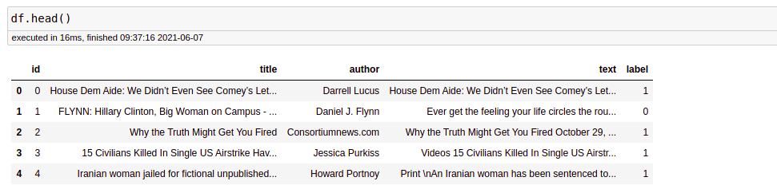

Passive Aggressive is considered algorithms that perform online learning (with for example Twitter data). Their characteristic is that they remain passive when dealing with an outcome that has been correctly classified, and become aggressive when a miscalculation takes place, thus constantly self-updating and adjusting.

# PASSIVE-AGGRESSIVE CLASSIFIER

from sklearn.metrics import accuracy_score

from sklearn.linear_model import PassiveAggressiveClassifier

pac=PassiveAggressiveClassifier(max_iter=50)

pac.fit(x_train,y_train)

#Predict on the test set and calculate accuracy

y_pred=pac.predict(x_test)

score=accuracy_score(y_test,y_pred)

print(f'Accuracy: {round(score*100,2)}%')

Output:

Accuracy: 93.12%

**Bert Model:**

BERT stands for (Bidirectional Encoder Representation from Transformers). BERT makes use of transformers. These transformers include two mechanisms an encoder and a decoder. BERT is an open-source machine learning framework for natural language processing (NLP). BERT is designed to help computers understand the meaning of ambiguous language in the text by using surrounding text to establish context. The BERT framework was pre-trained using text from Wikipedia and can be fine-tuned with question-and-answer.

**OUTPUT OF THE MODELS**



Fig:output for the real news



Fig:output for the fake news

## 

**FUTURE SCOPE**

* Natural Language Processing(NLP) : Integrating NLP techniques can enhance the accuracy of the system in detecting fake news ,by analyzing the sentiment and one of the news article.
* Incorporating multimedia content : The system can be further improved by incorporating multimedia content such as images and videos,to detect fake news that are propagated through such means.
* Mobile Application:Developing a mobile application for the system can make it more accessible to users on-to-go,thus enhancing its usability and user engagement.
* These are just a few of the potential areas for future development and improvement of the Fake News Detection System using Multinomial.

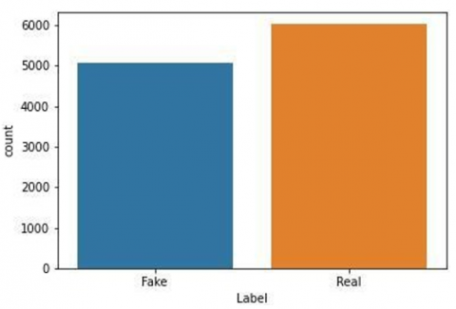

**IMPLEMENTATION**

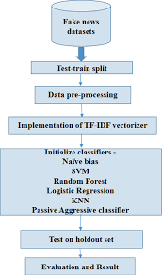

Above flowgraph shows the step by step process

## CONCLUSION

The passive-aggressive classifier performed the best here and gave an accuracy of 93.12%....

We can print a confusion matrix to gain insight into the number of false and true negatives and positives.

Fake news detection techniques can be divided into those based on style and those based on content, or fact-checking. Too often it is assumed that bad style (bad spelling, bad punctuation, limited vocabulary, using terms of abuse, ungrammaticality, etc.) is a safe indicator of fake news.

More than ever, this is a case where the machine’s opinion must be backed up by clear and fully verifiable indications for the basis of its decision, in terms of the facts checked and the authority by which the truth of each fact was determined.



**REFERENCES**

[1]. Meesad, P. Thai Fake News Detection Based on Information Retrieval, Natural Language Processing and Machine Learning. SN COMPUT.

SCI. 2, 425 (2021).

[2]. Uma Sharma, Sidarth Saran, Shankar M. Patil, 2021, Fake News Detection using Machine Learning Algorithms, INTERNATIONAL

JOURNAL OF ENGINEERING RESEARCH & TECHNOLOGY (IJERT) NTASU – 2020.

[3]. Sakeena M Sirajudeen, Nur Fataihah A Azmi, Adamul Abubakar, Online fake news detection algorithm, journal of theorical and Applied

information Technology, 2017

[4]. J. C. S. Reis, A. Correia, F. Murai, A. Veloso and F. Benevenuto, "Supervised Learning for Fake News Detection," in IEEE Intelligent Systems,

vol. 34, no. 2, pp. 76-81, March-April 2019

[5]. Jamal Abdul Nasir, Osama Subhani Khan, Iraklis Varlamis, Fake news detection: A hybrid CNN-RNN based deep learning approach,

International Journal of Information Management Data Insights, Volume 1, Issue 1, 2021.

[6]. Z. Shahbazi and Y.Byun, "Fake Media Detection Based on Natural Language Processing and Blockchain Approaches," in IEEE Access, vol.

9, pp, 2021

[7]. K. Shu, S. Wang and H. Liu, "Understanding User Profiles on Social Media for Fake News Detection," 2018 IEEE Conference on Multimedia

Information Processing and Retrieval (MIPR), 2018, pp. 430-435.

[8]. Ahmad, T.; Faisal, M.S.; Rizwan, A.; Alkanhel, R.; Khan, P.W.; Muthanna, A. Efficient Fake News Detection Mechanism Using Enhanced

Deep Learning Model. Appl. Sci. 2022, 12, 1743.

[9]. Kai Shu, Amy Sliva, Suhang Wang, Jiliang Tang, and Huan Liu. 2017. Fake News Detection on Social Media: A Data Mining Perspective.

SIGKDD Explor. Newsl. 19.

[10]. Kaliyar, R.K., Goswami, A. & Narang, P. DeepFakE: improving fake news detection using tensor decomposition-based deep neural network. J

Supercomput 77, 1015–1037 (2021).

[11]. Zervopoulos A., Alvanou A.G., Bezas K., Papamichail A., Maragoudakis M., Kermanidis K. (2020) Hong Kong Protests: Using Natural

Language Processing for Fake News Detection on Twitter. In: Maglogiannis I., Iliadis L., Pimenidis E. (eds) Artificial Intelligence pplications

and Innovations. AIAI 2020. IFIP Advances in Information and Communication Technology, vol 584. Springer

[12]. “Fake News Detection using Machine Learning and Natural Language Processing” Kushal Agarwalla, Shubham Nandan, Varun Anil Nair,

D. Deva Hema, IJRTE, Vol-6, Issue-6, March 2019

[13]. A HYBRID APPROACH TO FAKE NEWS DETECTION ON SOCIAL MEDIA E. M. Okoro1,*, B. A. Abara2, A. O. Umagba3, A. A.

Ajonye4 and Z. S. Isa, 2018

[14]. Bharadwaj, Pranav and Shao, Zongru, Fake News Detection with Semantic Features and Text Mining (July 24, 2019). International Journal

on Natural Language Computing (IJNLC) Vol.8, No.3, June 2019

[15]. Fake News Detection Using Machine Learning Approaches, B N Alwasel1, H Sirafi1 and M Rashid, Z Khanam et al 2021.